VPC-Transit -Gateway and VPC Endpoints Challenge

Use Case: Setting up Transit Gateway and VPC Endpoints for a Multi-VPC Architecture
Scenario:
A large organization is migrating its on-premises infrastructure to the AWS cloud.
The organization's architecture involves multiple VPCs for different departments and applications, each requiring secure communication with centralized services and external resources.
The IT team needs to design and implement a scalable and efficient network architecture to accommodate the organization's growth and ensure robust connectivity between VPCs and external services.
Objectives:
- Design and deploy a scalable network architecture using AWS Transit Gateway to simplify network connectivity between multiple VPCs.
- Configure VPC endpoints to securely access AWS services without internet gateways or NAT gateways, ensuring data privacy and minimizing exposure to external threats.

Configure Transit Gateway
Steps:
- Go to AWS Console → VPC → Transit Gateways.
- Click Create transit gateway.
- Enter the name:
Task4-Transit-Gateway
- Leave the remaining settings as default and click Create transit gateway.
- Wait until the Transit Gateway state becomes Available.
- Go to Transit Gateway Attachments.
- Click Create transit gateway attachment.
- Select:
  - Transit Gateway: Task4-Transit-Gateway
  - Attachment type: VPC
  - VPC: Today-Task-VPC
- Select the required subnet(s) for the VPC attachment.
- Click Create transit gateway attachment.
- Wait until the attachment state becomes Available.
- Go to Transit Gateway Route Tables and verify the route table.
- Verify that the VPC attachment is associated with the Transit Gateway route table.
- Verify that the required VPC routes are active.
Resources Created
- Transit Gateway: tgw-0833369c2005363e6
- VPC Attachment: tgw-attach-04595a3c64ad7be79
- Attachment Status: Available ✅
- Transit Gateway Route Table: tgw-rtb-07368c1d7cf9ef9cc
- Route Table Status: Available ✅
Routes Verified
- 10.0.0.0/16 → VPC attachment → Active ✅
- 10.20.0.0/16 → VPC attachment → Active ✅
Conclusion:
Transit Gateway was successfully created, the VPC was attached, and the required routes were configured and verified as active.

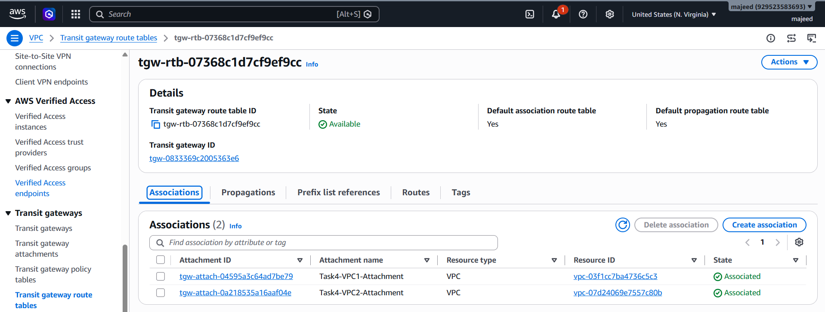
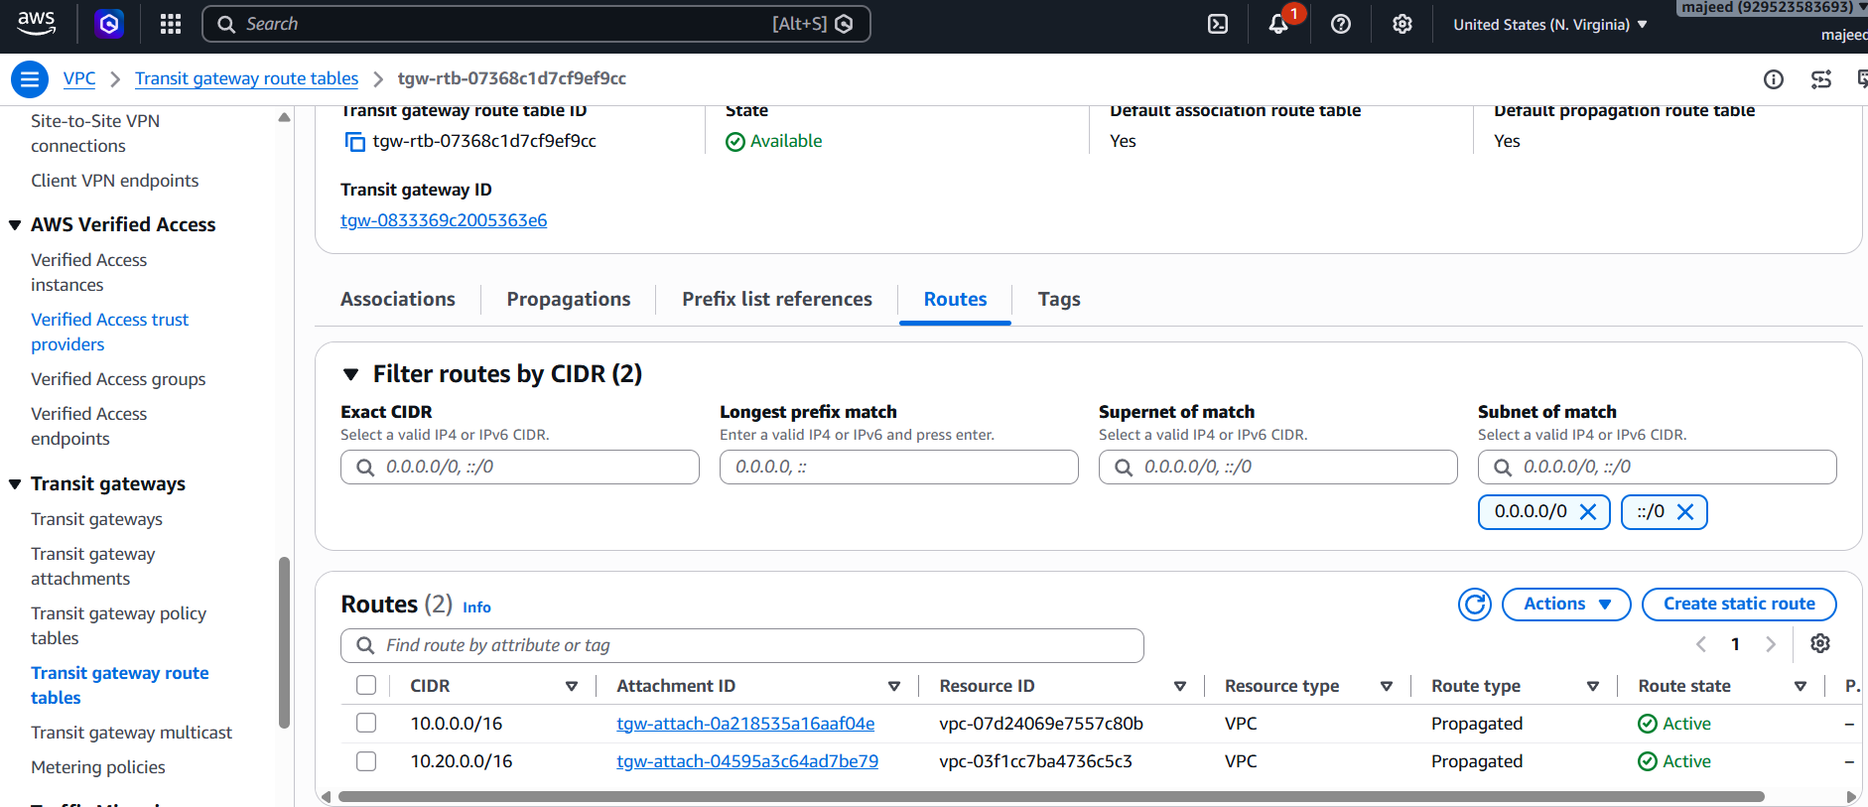

Now we configure the VPC Endpoint:
Purpose:
A VPC Endpoint allows resources inside a VPC to access Amazon S3 without going through the Internet Gateway or NAT Gateway.
Steps
- Open AWS Console → VPC.
- In the left menu, select Endpoints.
- Click Create endpoint.
- Enter a name, for example:
S3-VPC-Endpoint
- Under Service category, select:
AWS services
- Search for and select:
S3
  - Service: com.amazonaws.us-east-1.s3
- For VPC, select your VPC:
vpc-07d24069e7557c80b
- For Endpoint type, select:
Gateway
- Under Route tables, select the route table associated with the subnet that needs S3 access.
- Leave the policy as Full Access for the lab/practice setup.
- Click Create endpoint.

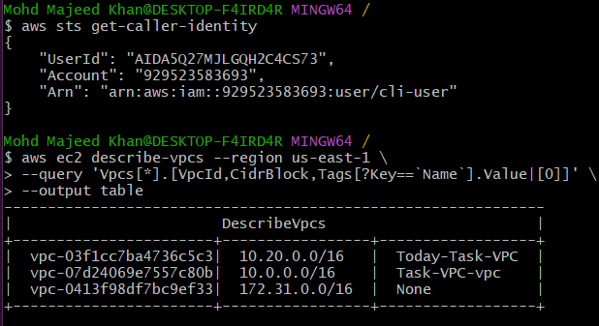
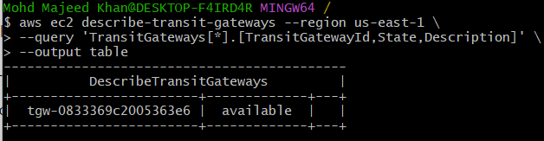

VPC Endpoint
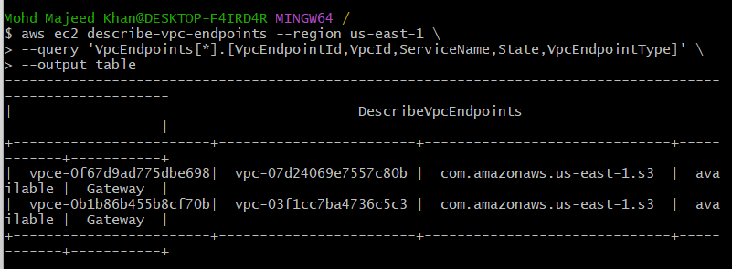

The goal of the Transit Gateway part
You want to connect multiple VPCs through one central Transit Gateway.
The logical order is:
1. Create VPC 1
↓
2. Create VPC 2
↓
3. Create Transit Gateway
↓
4. Create Transit Gateway Attachment
↓
Attach VPC 1 → Transit Gateway
↓
5. Create another Attachment
↓
Attach VPC 2 → Transit Gateway
↓
6. Configure/verify Transit Gateway routes

VPC End Points :
If you did not have any route table at first, then you would need to create a route table first for the VPC/subnet that will use the S3 Gateway Endpoint. ✅
The flow would be:
1. Create VPC
↓
2. Create Subnet
↓
3. Create Route Table
↓
4. Associate Route Table with Subnet
↓
5. Create S3 VPC Endpoint
↓
6. Select that Route Table
↓
7. Endpoint = Available

